USER MANUAL

Lite Version HDBaseT HDMI Extender-HDBT-HD-70-MTK
4K60(4:2:0), HDMI2.0, HDCP2.2, POC，CEC

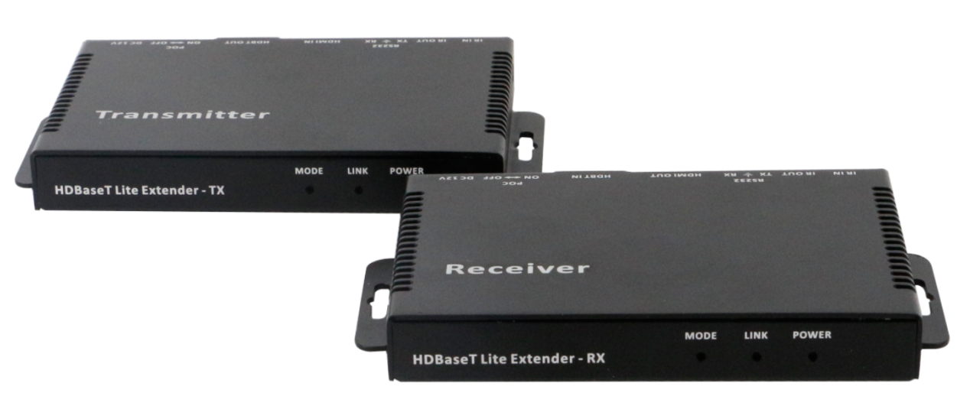

*Note: This is a common user manual for all the lite version HDBaseT extenders, the chassis might be different as the different production version or it’s customized. Please refer to the real equipment.

Version: V2.0.1

1. Introduction
This lite version extender is using the HDBaseT technology, it supports no compression, no losses, no latency HDMI signal transmission. It can can work with other HDBaseT equipment, such as Sony HDBaseT projector. All the signals are transmitted by one single CAT5E/ CAT6/ CAT7 cable, for 1080P it can transmit to a distance of 70m(230ft), for 4K60Hz(4:2:0) it can up to 35m(115ft). Compatible with all the HDTV resolutions, HDCP2.2 protocol. It also supports bi-directional RS232 and IR transmission and realize the long distance control. Supports power over cable, users only need to power one side; It can be popularly used in media conferencing room, school, government, cinema and so on applications.
- Features
- Transmit highest quality audio and video, for 1080p can up to 220 feet and 4K60(4:2:0) can up to 115feet with Cat6/6a/7 cable
- Supports FULL HD, UHD, 3D, 4K60Hz
- HDCP2.2, HDMI2.0
- Bidirectional IR/Serial control signal transmission
- Power over Cable (POC) locally powered over Cat5e/6 cable at either end
- Supports 7.1 DTS Master HD, Dolby True HD,
- LED indicators, EDID pass-though
- Supports CEC control
- Specification
Model | HDBaseT Lite Extender-Tx | HDBaseT Lite Extender-Rx
Input | 1*HDMI, 1*RS232, 1*IR-TX, 1*IR-RX | 1*HDBaseT
Output | 1*HDBaseT | 1*HDMI, 1*RS232, 1*IR-TX, 1*IR-RX
Protocol | Support HDMI2.0 and compatible with HDCP2.2
Resolution | 1920x1200, 1680x1050, 1360x768, 1280x800, 1920x1080, 1600x900, 1366x768, 1280x720, 1024x576, 1920x1200, 1680x1050, 1360x768, 1280x800, 4096x2160@30Hz, 3840x2160@30Hz, 3840x2160@60Hz
Color Space | 1080p: 36Bit Deep Color 4K: 24Bit True Color, 4:2:0
Bandwidth | 10.2Gbps
Transmission Distance | CAT5e/6 cable: 220FT/70m(1080p60Hz, 110FT/35m(4K60Hz)
Dimension | 115*84*16（mm）
Weight | 120g
Power | AC: 100-240V 50/60Hz 1.5A Max DC: 12V 1500mA
Consumption | ≤11W
Working Humidity | 10%-90%
Working Temperature | 0℃-50℃
Storage Temperature | -20℃-75℃

4. Packing
HDBaseT Lite Extender-Rx(Receiver) | 1 | pcs
HDBaseT Lite Extender-Tx(Transmitter) | 1 | pcs
Power adapter(DC 12V) | 1 | pcs

5. Panels
Transmitter
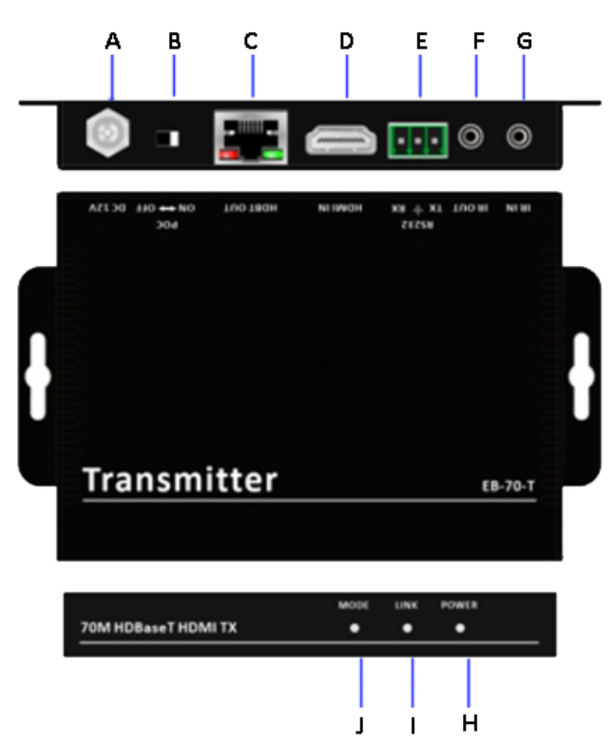
A: DC 12V input port
B: POC function OFF/ON switch
C: RJ45 output port
D: HDMI input port
E: 3-pin RS232 port
F: IR transmitter port
G: IR receiver port
H: POWER: The indicator will light up when power on
I: LINK: It will light up when the transmitter and receiver connected successfully, flecking means connection is not stable, off means the connection is failed.
J: MODE: It will flick once per second if the system runs good, on the contrary, it will be off
or light up.

Receiver
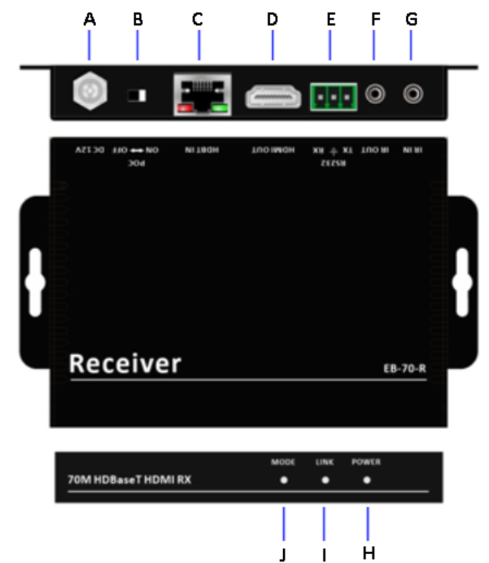
A: DC 12V input port
B: POC function OFF/ON switch
C: RJ45 input port
D: HDMI output port
E: 3-pin RS232 port
F: IR transmitter port
G: IR receiver port
H: POWER: The indicator will light up when power on
I: LINK: It will light up when the transmitter and receiver connected successfully, flecking means connection is not stable, off means the connection is failed.
J: MODE: It will flick once per second if the system runs good, on the contrary, it will be off
or light up.

6. Operation

6.1 Connection Diagram

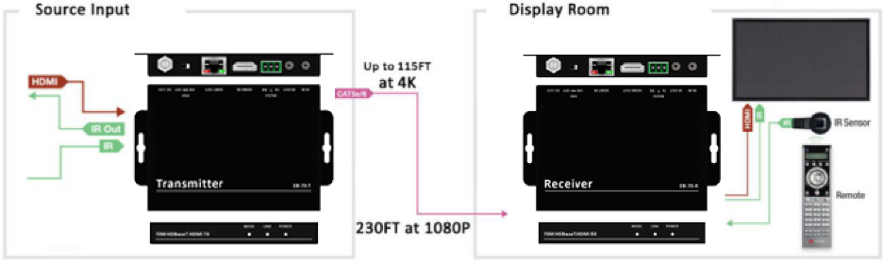

6.2 RJ-45 connector
Suggest to use twisted shield pair 24AWG cable, the bandwidth at least 400MHz, and crystal connector.
